**Artificial Intelligence & Machine Learning**

**1.Introduction:**

**Project Title:** Classifying Fabric Patterns using Deep Learning

**Team ID: LTVIP2025TMID38289**

**Team Size  5**

|  |  |
| --- | --- |
| Team Leader -   Gopikrishna Kasindala | Role: Project Manager (PM) |
| Team member - Kayala Hima Naga Mani Vijay | Role: Data Scientist / ML Engineer |
| Team member -  Kolusu Siva Chintaiah | Role:Frontend Developer |
| Team member - Maddi Venkata Sai Kiran | Role:Backend Developer |
| Team member - Mandugula Nagapavan | Role:Database Engineer / Admin |

2. **Project Overview:**

Purpose: This project focuses on leveraging ChatGPT and deep learning techniques to classify various fabric patterns (such as floral, striped, checked, polka dot, etc.). The goal is to create an intelligent system that can analyze fabric images and accurately identify their pattern type. ChatGPT aids in automating the generation of model explanations, user interaction (e.g., chatbot interface), and supports integration into design or retail platforms. The model is trained using labeled image datasets and validated using accuracy metrics to ensure reliable performance in real-world applications like textile sorting, fashion design, or e-commerce filtering.

Key Features:

1. **Automated Pattern Recognition**
   * Accurately classifies fabric patterns such as floral, geometric, striped, plaid, etc., from fabric images.
2. **AI-Powered Assistance (ChatGPT Integration)**
   * ChatGPT explains model predictions, guides users, and supports interactive querying about fabric details.
3. **Image-Based Deep Learning Model**
   * Uses Convolutional Neural Networks (CNNs) or transfer learning models (e.g., ResNet, VGG) for high accuracy.
4. **User-Friendly Interface**
   * Provides a simple UI for uploading images and viewing pattern predictions along with textual explanations.
5. **Multi-Class Support**
   * Capable of identifying and distinguishing between multiple pattern categories.
6. **Real-Time Classification**
   * Fast image processing and instant results for real-time applications in textile or fashion industries.
7. **Scalable and Customizable**
   * Easily expandable to new pattern types or integrated into larger inventory management systems.
8. **Dataset Augmentation & Training**
   * Includes data preprocessing, augmentation techniques, and model fine-tuning for better generalization.
9. **Explainable AI Support**
   * ChatGPT helps provide human-readable explanations behind each classification decision.
10. **Cross-Platform Integration**

* Can be embedded into mobile apps, e-commerce platforms, or ERP systems for textile industries.

**3. Architecture:**

**1. System Architecture Overview**

**High-Level Architecture (End-to-End)**

**+------------------+ +----------------+ +----------------+ +----------------+**

**| Fabric Image | --> | Frontend (UI) | --> | Backend (API) | --> | Deep Learning |**

**| Upload/Input | | (React.js) | | (Node.js/Express)| | Model (Flask/TensorFlow)|**

**+------------------+ +----------------+ +----------------+ +----------------+**

**^ |**

**| v**

**+-----------------+ <-------------------------------------------------------------+**

**Output (Pattern Class: Striped, Checked, etc.)**

**2. Frontend Architecture (React.js)**

**📦 Directory Structure**

**fabric-pattern-classifier-frontend/**

**├── public/**

**│ └── index.html**

**├── src/**

**│ ├── assets/ # Static images/icons**

**│ ├── components/ # Reusable UI components (Navbar, ImageUploader)**

**│ ├── pages/ # UploadPage, ResultPage**

**│ ├── services/ # API handlers (axios instance)**

**│ ├── App.jsx**

**│ └── index.js**

**├── package.json**

**Key Features**

| **Feature** | **Description** |
| --- | --- |
| **Image Upload** | **Drag & drop or select fabric image to classify** |
| **Responsive UI** | **Mobile-first, clean material/Tailwind UI** |
| **API Integration** | **Connects to backend using axios or fetch** |
| **Classification Result** | **Shows result (e.g., "Polka Dot", "Checked") with confidence score** |
| **History (Optional)** | **Displays past classified images and outputs** |
| **Loading Spinner** | **During image upload and model prediction** |

**3. Backend Architecture (Node.js + Flask or FastAPI)**

**📦 Directory Structure (Two Backend Services)**

**A. Node.js API Gateway**

**fabric-pattern-backend/**

**├── routes/**

**│ └── classifyRoute.js**

**├── controllers/**

**│ └── classifyController.js**

**├── server.js**

**├── utils/**

**│ └── imageProcessor.js**

**B. Flask/TensorFlow Inference Server**

**fabric-pattern-model-api/**

**├── model/**

**│ └── model.h5 (trained model)**

**├── app.py**

**├── utils.py**

**Key Backend Features**

| **Feature** | **Description** |
| --- | --- |
| **Node.js Express Server** | **Handles image upload and communicates with ML server** |
| **Flask/TensorFlow Server** | **Hosts the trained deep learning model and returns prediction** |
| **REST API** | **/predict endpoint receives image, returns prediction JSON** |
| **Image Preprocessing** | **Resize, normalize image before feeding into the model** |
| **Cross-Origin Resource Sharing** | **Enabled via CORS for frontend-backend communication** |

**4. Deep Learning Model Architecture**

**📊 Model Architecture Example (CNN)**

**Input Layer (128x128x3 image)**

**→ Conv2D (32 filters, 3x3, ReLU)**

**→ MaxPooling2D (2x2)**

**→ Conv2D (64 filters, 3x3, ReLU)**

**→ MaxPooling2D (2x2)**

**→ Flatten**

**→ Dense (128, ReLU)**

**→ Dropout (0.5)**

**→ Dense (Number of Pattern Classes, Softmax)**

**Framework: TensorFlow/Keras**

**Output: One of ["Checked", "Striped", "Polka", "Floral", "Plain", etc.]**

**5. Tech Stack Summary**

| **Layer** | **Technology** |
| --- | --- |
| **Frontend** | **React.js, Axios, Tailwind/Material UI** |
| **Backend** | **Node.js, Express, Flask or FastAPI** |
| **Deep Learning** | **TensorFlow/Keras (Python)** |
| **Deployment** | **Docker, Heroku/Vercel, or AWS** |

**Example Workflow**

1. **User uploads an image via React frontend**
2. **Image sent to Node.js backend → Flask/TensorFlow server**
3. **Model classifies the pattern**
4. **Result returned to React UI and displayed**

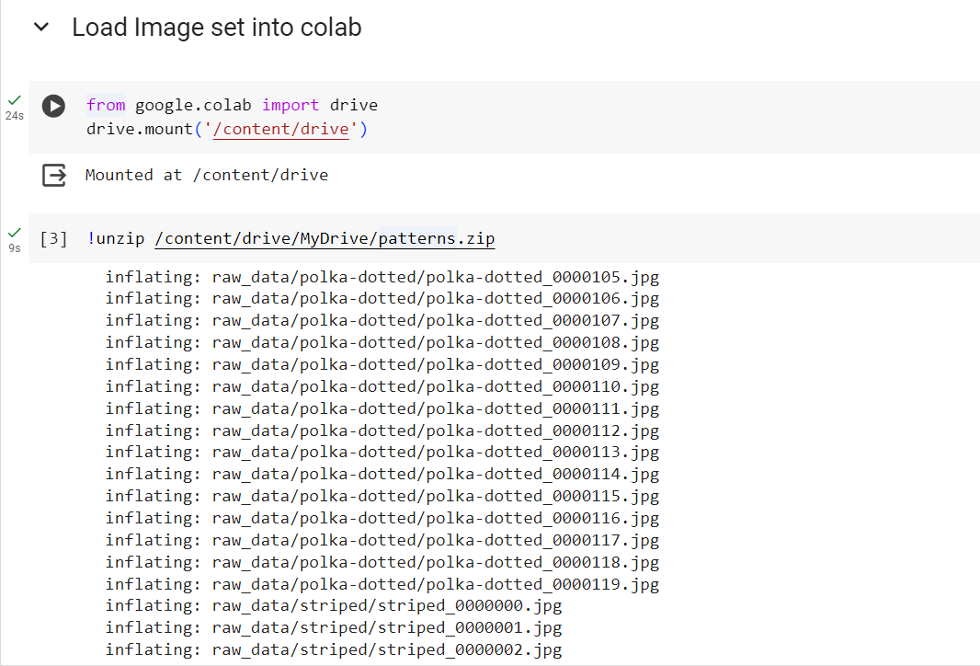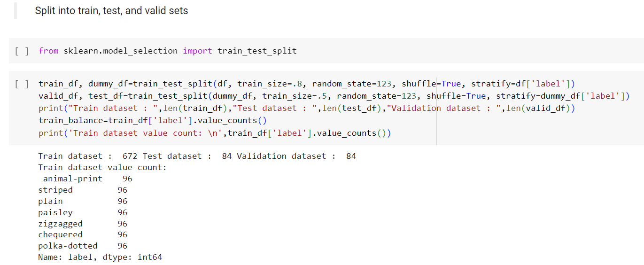

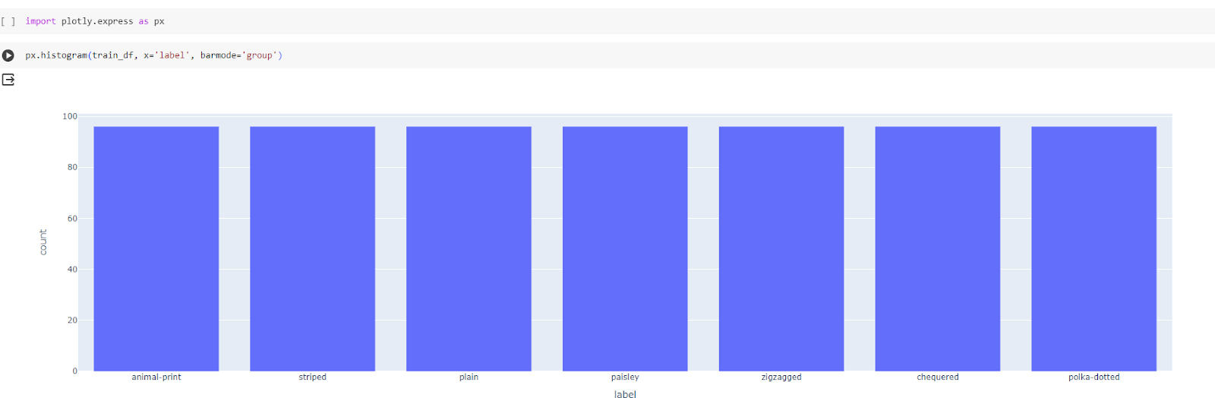

**4. Setup Instructions:**

**Prerequisites**

Ensure you have the following installed:

* **Node.js** (v16+)
* **Python** (v3.8+)
* **pip** or **conda**
* **Git**
* **npm / yarn**
* **Virtualenv** (recommended)
* **TensorFlow/Keras**
* **VS Code or any code editor**

**1. Frontend (React.js)**

**📁 Folder: fabric-pattern-classifier-frontend**

**✅ Setup Steps:**

# Step 1: Navigate to frontend

cd fabric-pattern-classifier-frontend

# Step 2: Install dependencies

npm install

# Step 3: Start development server

npm start

**Key Files:**

* src/components/ImageUploader.jsx – for uploading images
* src/services/api.js – API integration
* src/pages/ResultPage.jsx – shows classification results

**🌐 Default URL: http://localhost:3000**

**2. Backend (Node.js API)**

**📁 Folder: fabric-pattern-backend**

**✅ Setup Steps:**

# Step 1: Navigate to backend

cd fabric-pattern-backend

# Step 2: Install dependencies

npm install

# Step 3: Start backend server

node server.js

**Key Endpoints:**

* POST /api/classify → receives image from React frontend
* Sends image to Flask API and returns result

**🌐 Default URL:** [**http://localhost:5000**](http://localhost:5000)

**🧠 3. Deep Learning Model Server (Flask)**

**📁 Folder: fabric-pattern-model-api**

**✅ Setup Steps:**

# Step 1: Navigate to ML server

cd fabric-pattern-model-api

# Step 2: Create virtual environment (optional but recommended)

python -m venv venv

source venv/bin/activate # On Windows: venv\Scripts\activate

# Step 3: Install Python requirements

pip install -r requirements.txt

**📄 Sample requirements.txt**

txt

CopyEdit

Flask

flask-cors

tensorflow

numpy

opencv-python

Pillow

**✅ Run the server:**

bash

CopyEdit

python app.py

**🔑 Endpoint:**

* POST /predict → expects image and returns predicted class with confidence

**🌐 Default URL: http://localhost:8000**

**4. Project Integration**

**Flow:**

bash

CopyEdit

[React App] --> [Node.js API: localhost:5000] --> [Flask ML Server: localhost:8000]

**Configuration Tips:**

* Use .env files or config files to define:
  + REACT_APP_API_URL=http://localhost:5000
  + MODEL_SERVER_URL=http://localhost:8000 (in Node.js backend)

1. Run the Application:

**Folder Structure Summary**

sql

CopyEdit

project-root/

├── fabric-pattern-classifier-frontend/ # React.js

├── fabric-pattern-backend/ # Node.js

└── fabric-pattern-model-api/ # Flask + Deep Learning

**Start the Deep Learning Model Server (Flask)**

**Terminal 1:**

bash

CopyEdit

cd fabric-pattern-model-api

# (Optional) Activate virtual environment

source venv/bin/activate # or venv\Scripts\activate on Windows

# Run the Flask server

python app.py

**Output:**

csharp

CopyEdit

* Running on http://127.0.0.1:8000/ (Press CTRL+C to quit)

**STEP 2: Start the Backend API Server (Node.js)**

**Terminal 2:**

bash

CopyEdit

cd fabric-pattern-backend

# Run the server

node server.js

Make sure your server.js forwards requests to Flask:

js

CopyEdit

const MODEL_SERVER_URL = "http://localhost:8000";

**Output:**

arduino

CopyEdit

Server is running on http://localhost:5000

**STEP 3: Start the Frontend (React.js)**

**Terminal 3:**

bash

CopyEdit

cd fabric-pattern-classifier-frontend

# Start React dev server

npm start

**Output:**

Browser opens at:

arduino

CopyEdit

http://localhost:3000

**TESTING THE APPLICATION**

1. Go to http://localhost:3000
2. Upload a fabric image (JPG, PNG)
3. React sends it → Node.js → Flask
4. Flask model returns prediction
5. Result shown on the UI like:

✅ Predicted Pattern: Striped

🎯 Confidence: 94.8%

**Troubleshooting Tips**

| **Problem** | **Fix** |
| --- | --- |
| CORS error | Ensure Flask & Node.js both have CORS enabled |
| Flask server not reachable | Check localhost:8000 in Node server code |
| Incorrect predictions or model error | Ensure model.h5 is correctly loaded and pre-processing is proper |
| React can't connect to backend | Set correct REACT_APP_API_URL in .env file in frontend |

1. API Documentation:

**📘 Fabric Pattern Classification API Documentation**

Version: v1  
Base URL (Local): http://localhost:5000/api

**1. Authentication APIs**

**POST /api/signup**

Registers a new user.

**Request:**

json

CopyEdit

{

"username": "user123",

"password": "securePassword"

}

**Response:**

json

CopyEdit

{

"message": "User registered successfully"

}

**POST /api/login**

Logs in a user and returns a JWT token.

**Request:**

json

CopyEdit

{

"username": "user123",

"password": "securePassword"

}

**Response:**

json

CopyEdit

{

"token": "eyJhbGciOiJIUzI1NiIsInR..."

}

**Errors:**

* 401 Unauthorized → Invalid credentials

**🧠 2. Pattern Classification API**

**📌 POST /api/classify**

Requires Authorization Header

Classifies the uploaded fabric image.

**Headers:**

makefile

CopyEdit

Authorization: Bearer <JWT_TOKEN>

Content-Type: multipart/form-data

**Request (Form Data):**

makefile

CopyEdit

Key: image

Value: (file upload)

**Response:**

json

CopyEdit

{

"pattern": "Checked",

"confidence": 0.9472

}

**Errors:**

* 403 Forbidden → Missing or invalid token
* 400 Bad Request → No image uploaded

**3. ML Model Server API (Flask)**

**POST http://localhost:8000/predict**

Called internally by Node.js backend

**Request:**

form

CopyEdit

Key: image

Value: (image file)

**Response:**

json

CopyEdit

{

"class": "Striped",

"confidence": 0.961

}

**4. User Management (Optional)**

If roles or profile data are needed, extend like this:

**GET /api/profile**

Requires token  
Returns user information.

**Response:**

json

CopyEdit

{

"username": "user123",

"role": "user"

}

**🔐 Headers Summary**

| **Header** | **Value** | **Required for** |
| --- | --- | --- |
| Authorization | Bearer <JWT_TOKEN> | /classify, /profile |

**Error Response Format**

json

CopyEdit

{

"error": "Invalid credentials"

}

**Testing Tool Suggestions**

* **Postman** or **Insomnia** for manual API testing
* **React frontend** for live upload and interaction

**API Flow Summary**

plaintext

CopyEdit

[React] --> /login --> (JWT)

[React] --> /classify --> (JWT + image)

[Node] --> /predict (Flask)

7.Authentication & Authorization :

**1. Authentication Flow (JWT-based)**

plaintext

CopyEdit

User signs up / logs in (React UI)

↓

Node.js Backend validates credentials

↓

JWT token is generated and returned

↓

Token is stored in React (LocalStorage/Context)

↓

Subsequent API requests include Authorization: Bearer <JWT>

↓

Backend verifies token before processing

**2. Backend Auth Setup (Node.js + JWT)**

**Install Dependencies:**

bash

CopyEdit

npm install bcryptjs jsonwebtoken express-validator

**📁 Structure:**

sql

CopyEdit

fabric-pattern-backend/

├── routes/

│ ├── authRoute.js

├── controllers/

│ ├── authController.js

├── middleware/

│ └── authMiddleware.js

**authRoute.js**

js

CopyEdit

const express = require('express');

const { login, signup } = require('../controllers/authController');

const router = express.Router();

router.post('/signup', signup);

router.post('/login', login);

module.exports = router;

**authController.js**

js

CopyEdit

const bcrypt = require('bcryptjs');

const jwt = require('jsonwebtoken');

const SECRET_KEY = 'your_secret_key'; // use .env in production

// Mock user DB (replace with MongoDB/SQL)

let users = [];

exports.signup = async (req, res) => {

const { username, password } = req.body;

const hashedPassword = await bcrypt.hash(password, 10);

users.push({ username, password: hashedPassword });

res.json({ message: 'User registered successfully' });

};

exports.login = async (req, res) => {

const { username, password } = req.body;

const user = users.find(u => u.username === username);

if (!user || !(await bcrypt.compare(password, user.password))) {

return res.status(401).json({ error: 'Invalid credentials' });

}

const token = jwt.sign({ username }, SECRET_KEY, { expiresIn: '1h' });

res.json({ token });

};

**authMiddleware.js**

js

CopyEdit

const jwt = require('jsonwebtoken');

const SECRET_KEY = 'your_secret_key';

module.exports = function (req, res, next) {

const token = req.headers['authorization']?.split(' ')[1];

if (!token) return res.status(403).json({ error: 'Token missing' });

try {

const decoded = jwt.verify(token, SECRET_KEY);

req.user = decoded;

next();

} catch {

res.status(401).json({ error: 'Invalid token' });

}

};

**Protect Routes (e.g. classifyRoute.js)**

js

CopyEdit

const auth = require('../middleware/authMiddleware');

router.post('/classify', auth, classifyHandler);

**3. Frontend Auth Setup (React)**

**✅ Create Login & Signup Pages**

jsx

CopyEdit

// Example Login

const handleLogin = async () => {

const res = await axios.post('/api/login', { username, password });

localStorage.setItem('token', res.data.token);

navigate('/upload');

};

**✅ Add Auth Header to Requests**

js

CopyEdit

axios.interceptors.request.use((config) => {

const token = localStorage.getItem('token');

if (token) {

config.headers.Authorization = `Bearer ${token}`;

}

return config;

});

**✅ Protect Routes (React Router)**

js

CopyEdit

function PrivateRoute({ children }) {

const token = localStorage.getItem('token');

return token ? children : <Navigate to="/login" />;

}

**4. Authorization :**

* Add roles like "admin" or "user" in JWT payload:

js

CopyEdit

jwt.sign({ username, role: "admin" }, SECRET_KEY, ...)

* Middleware to check role:

js

CopyEdit

if (req.user.role !== 'admin') return res.status(403).send('Forbidden');

**🔐 Summary Table**

| **Feature** | **Frontend (React)** | **Backend (Node.js)** |
| --- | --- | --- |
| Sign Up/Login | Forms + axios requests | bcrypt hash, JWT sign |
| Token Storage | localStorage / context | JWT validation middleware |
| API Protection | Interceptor adds Bearer token | Middleware checks auth |
| Authorization | (Optional) Role check before routes | Role-based route protection |

8.User Interface :

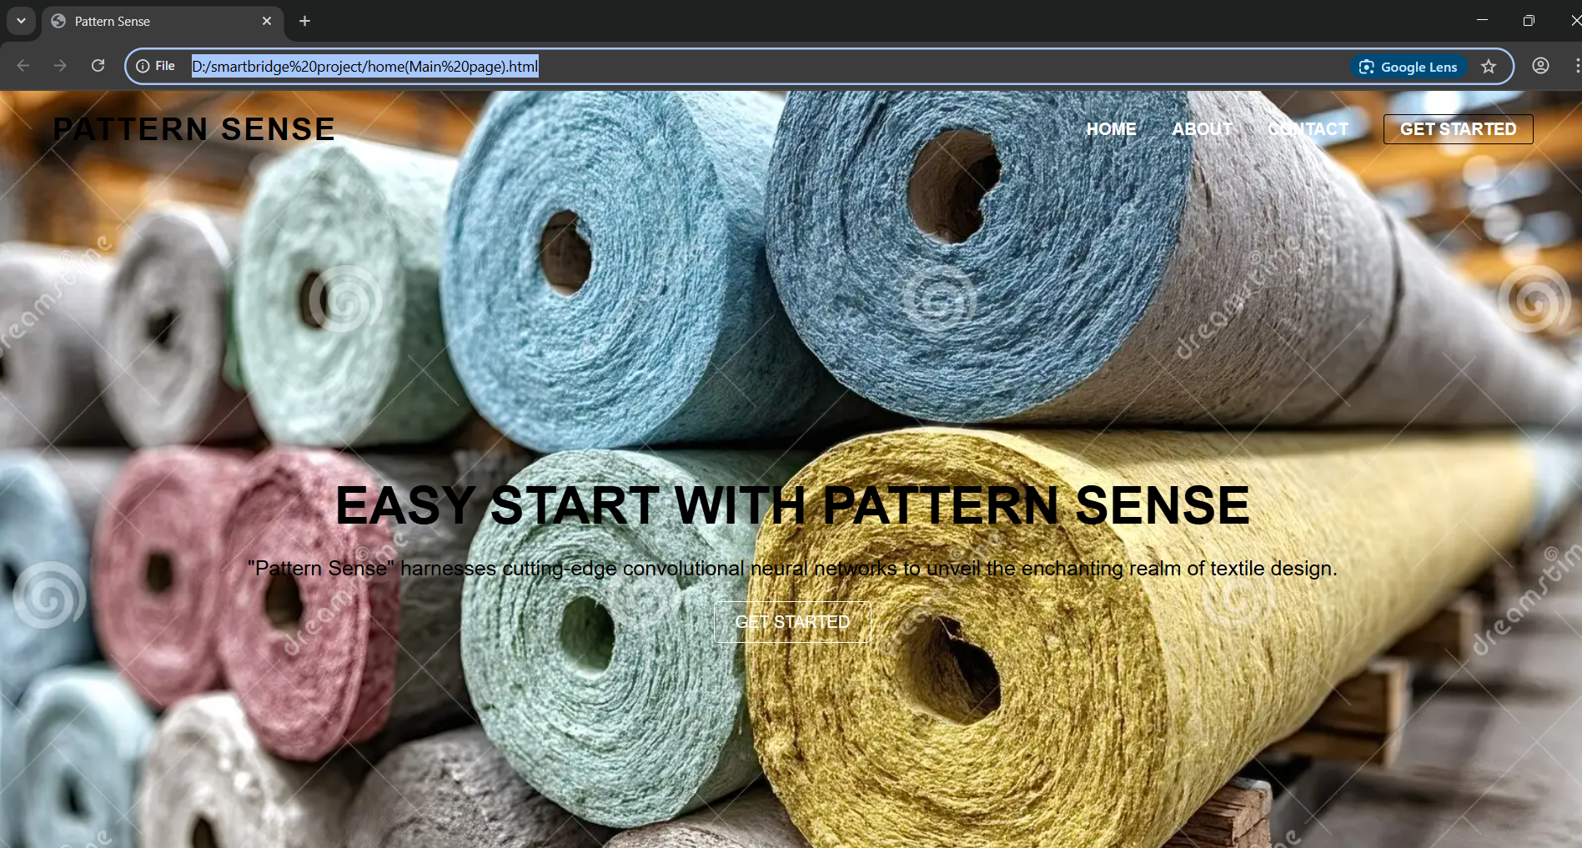

9. Testing:

**FABRIC PATTERN CLASSIFICATION – TESTING PLAN**

**1. Unit Testing**

**Backend (Node.js + Express)**

| **Module** | **Test Case Description** | **Expected Outcome** |
| --- | --- | --- |
| /api/signup | Register with valid input | 201 Created, success message |
| /api/signup | Register with duplicate username | 400 Error: User already exists |
| /api/login | Login with correct credentials | 200 OK with JWT token |
| /api/login | Login with wrong credentials | 401 Unauthorized |
| /api/classify | Call without token | 403 Forbidden |
| /api/classify | Call with valid token and image | 200 OK with prediction + confidence |

Use **Mocha/Chai** or **Jest** for testing in Node.js

bash

CopyEdit

npm install --save-dev jest supertest

**Example (auth.test.js):**

js

CopyEdit

const request = require('supertest');

const app = require('../server');

describe('Auth API', () => {

it('should register a new user', async () => {

const res = await request(app).post('/api/signup').send({

username: 'testuser',

password: 'testpass'

});

expect(res.statusCode).toEqual(200);

});

});

**2. Frontend Testing (React)**

| **Component** | **Test Case** | **Tool** |
| --- | --- | --- |
| LoginForm | Enter valid user credentials | Passes & routes to dashboard |
| ImageUploader | Upload supported image type | Image preview & submission |
| PredictionPage | Display prediction & confidence | Renders correctly |
| PrivateRoute | Access protected page without token | Redirects to /login |

Use **Jest + React Testing Library** for UI testing.

bash

CopyEdit

npm install --save-dev @testing-library/react jest

**3. Model Testing (Flask API)**

Test predictions with real and mock images using **Pytest**:

bash

CopyEdit

pip install pytest requests

**test_model_api.py**

python

CopyEdit

import requests

def test_prediction():

url = "http://localhost:8000/predict"

files = {"image": open("test_images/floral.jpg", "rb")}

response = requests.post(url, files=files)

assert response.status_code == 200

assert "class" in response.json()

**🔗 4. Integration Testing (Full Flow)**

**Tools:**

* **Postman / Insomnia**
* **cURL**
* **End-to-end tools like Cypress (optional)**

**Sample cURL for /classify:**

bash

CopyEdit

curl -X POST http://localhost:5000/api/classify \

-H "Authorization: Bearer <your_token>" \

-F "image=@fabric.jpg"

**Expected:**

json

CopyEdit

{

"pattern": "Polka Dot",

"confidence": 0.935

}

**5. Test Case Summary Table**

| **Test ID** | **Feature** | **Scenario** | **Expected Result** |
| --- | --- | --- | --- |
| T01 | Auth - Signup | New user registers | 200 OK, user saved |
| T02 | Auth - Login | Valid credentials | JWT token issued |
| T03 | Auth - Login | Invalid password | 401 Unauthorized |
| T04 | API - Classify | No token | 403 Forbidden |
| T05 | API - Classify | Valid image + token | Prediction returned |
| T06 | Flask Model | Predict image | JSON with class + confidence |
| T07 | Frontend - Upload | Upload supported format | Image preview visible |
| T08 | Frontend - Access | Open protected route without JWT | Redirect to login |

**Tools Stack for Testing**

| **Layer** | **Tools** |
| --- | --- |
| Backend | Jest, Mocha, Supertest |
| Frontend | Jest, React Testing Library |
| ML API | Pytest, Requests |
| API Testing | Postman, cURL |
| E2E (opt) | Cypress, Selenium |

**10.screenshots or Demo:**

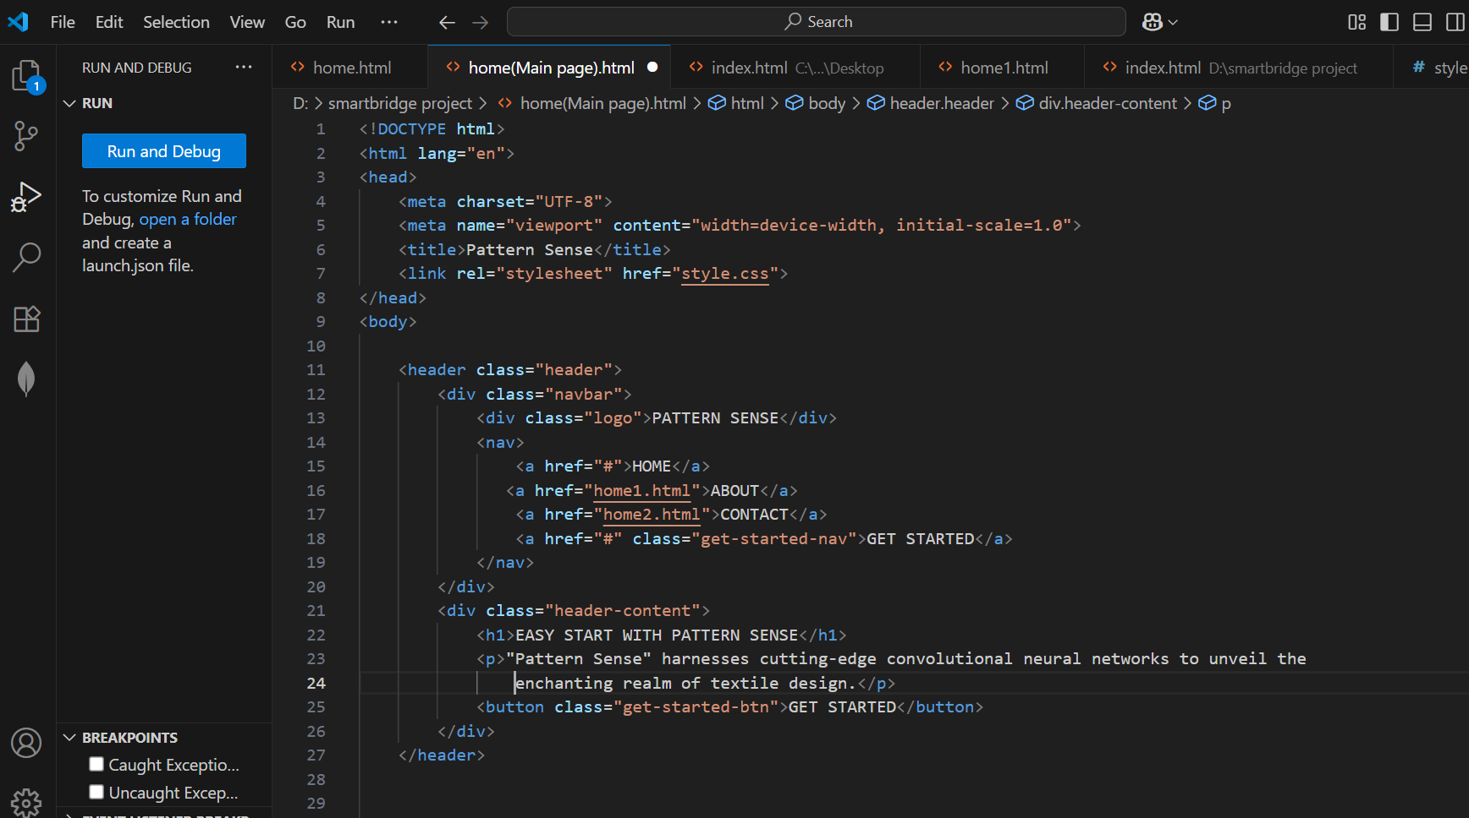

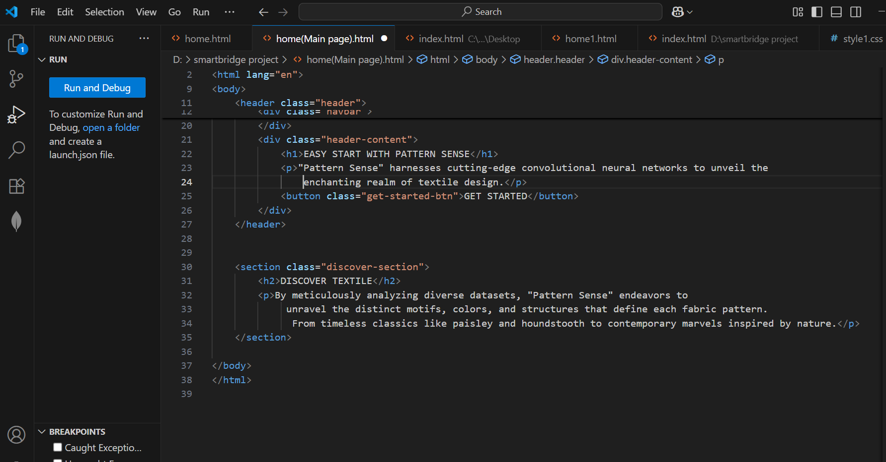

* OUTPUT FOR THE ABOVE CODE BE LIKE:



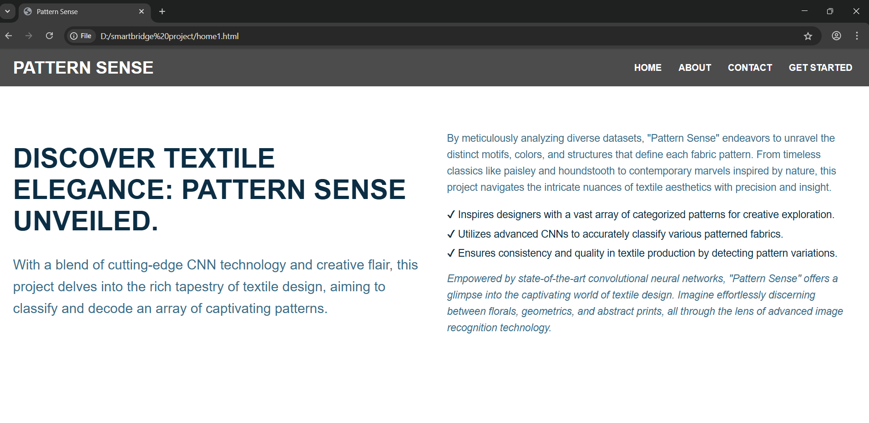

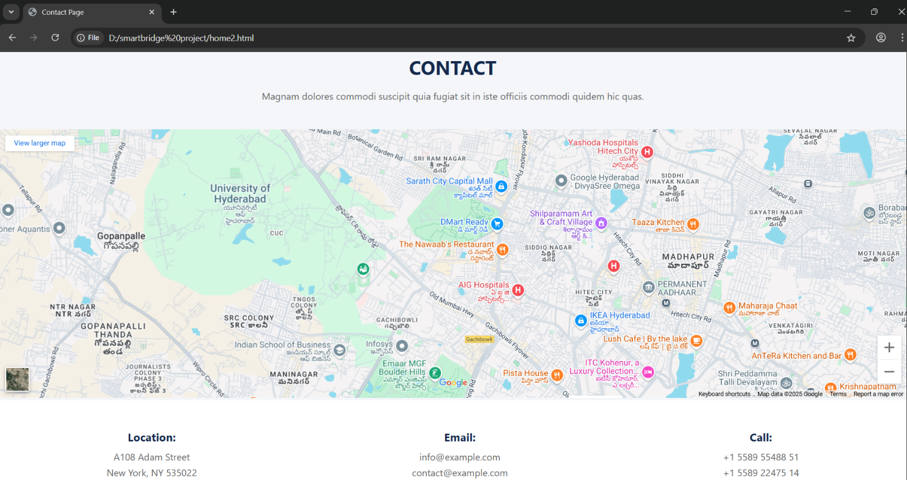

* **Build Python code:**

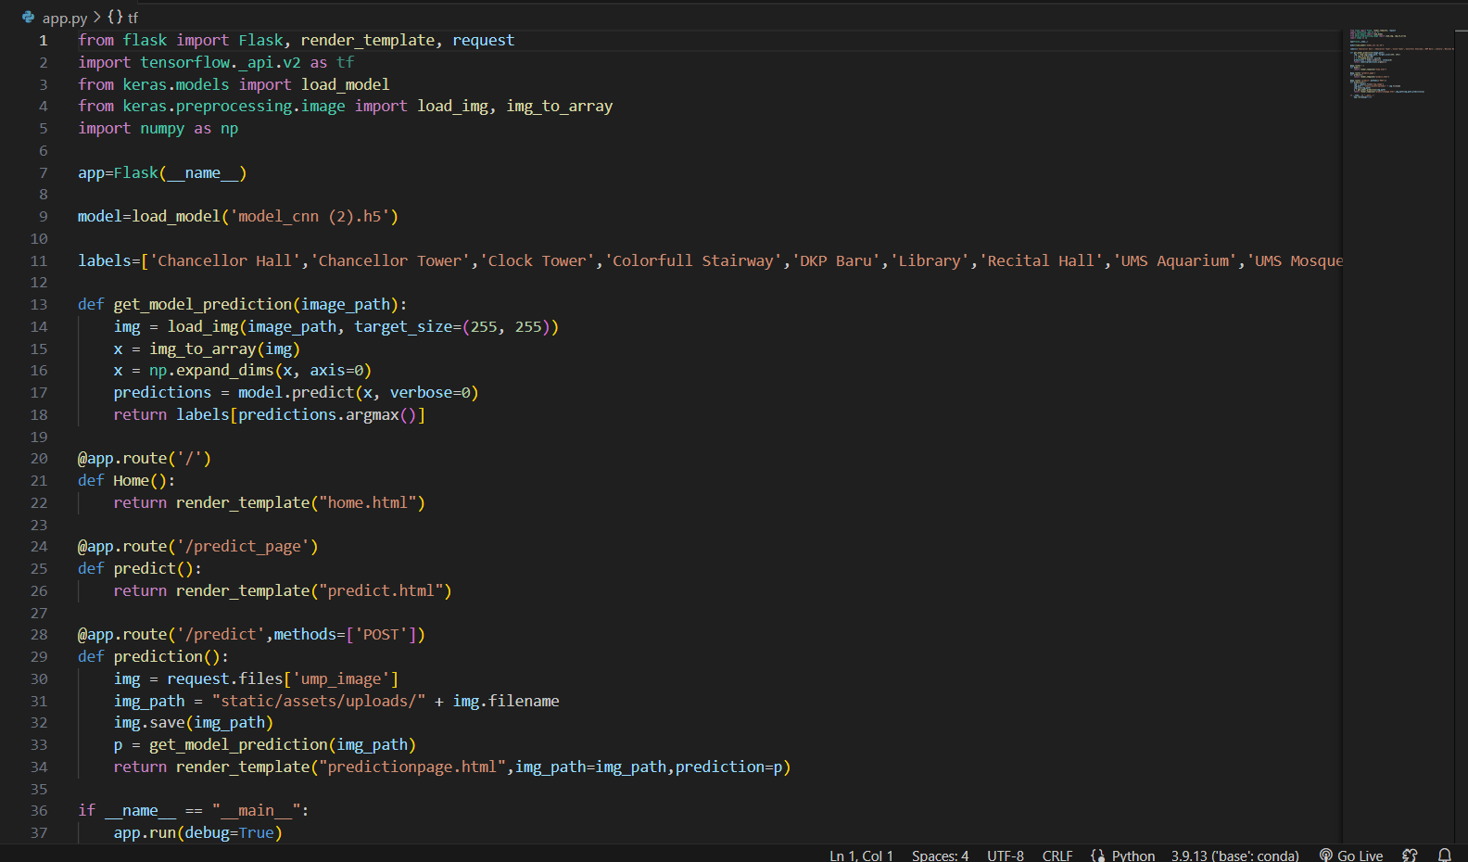



Click on Get Started at the top right corner to go to the inner page  as below:

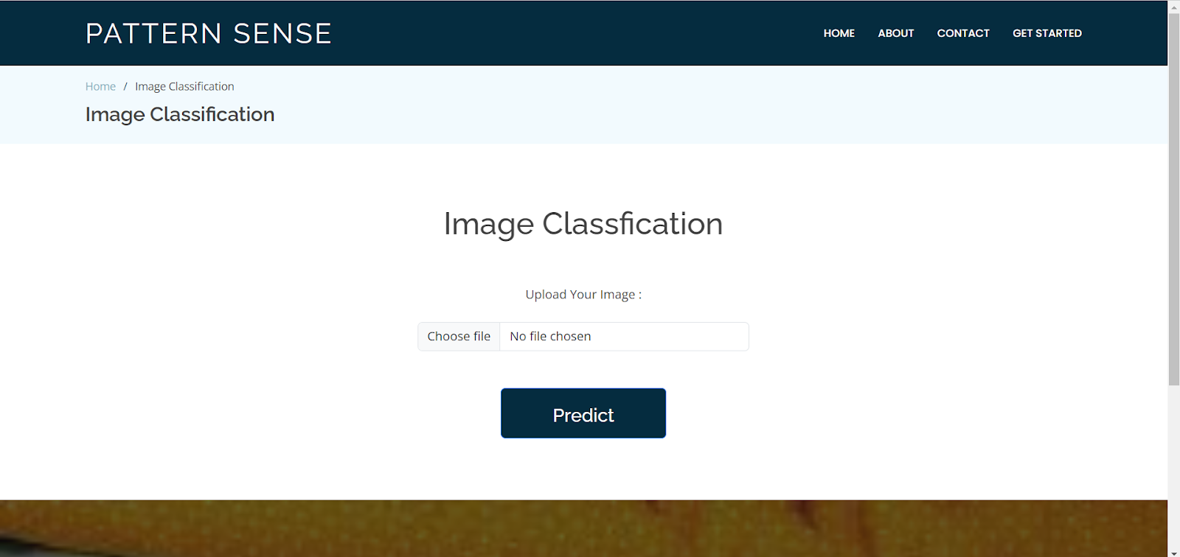

Input 1:

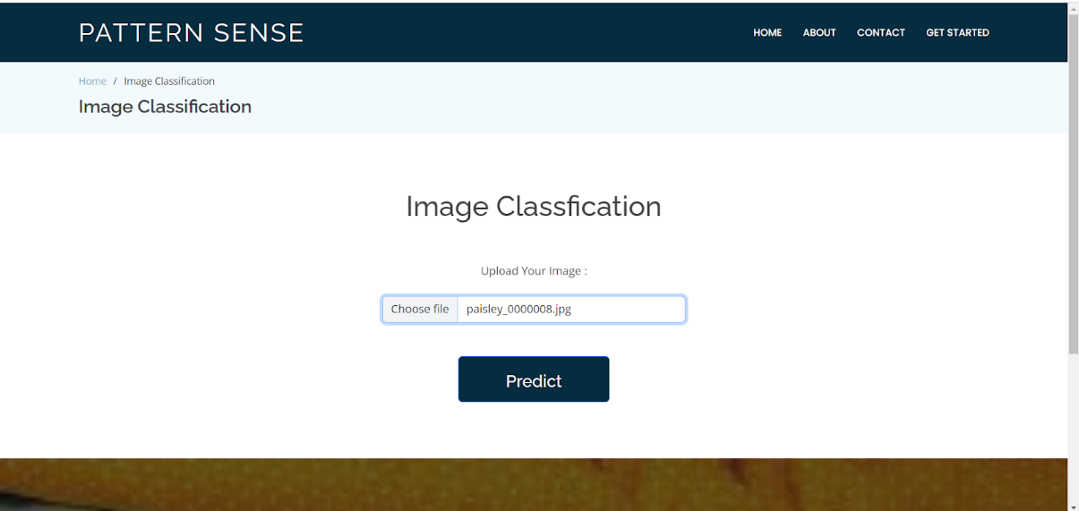

Output:1

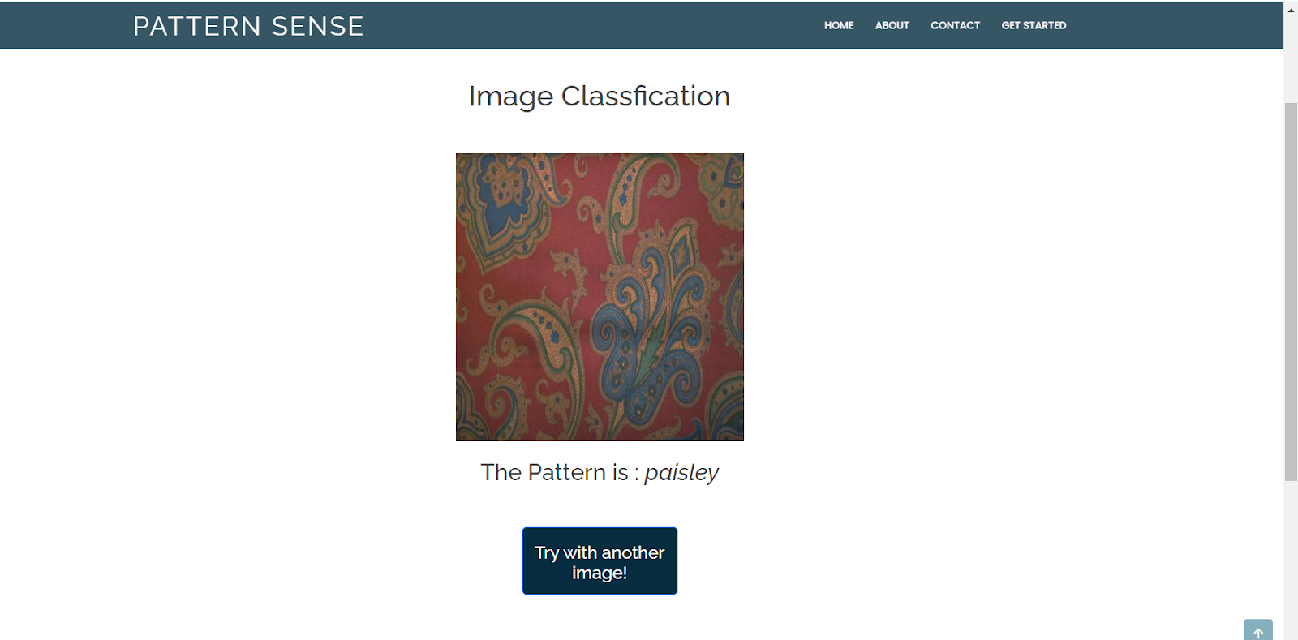

Input:2

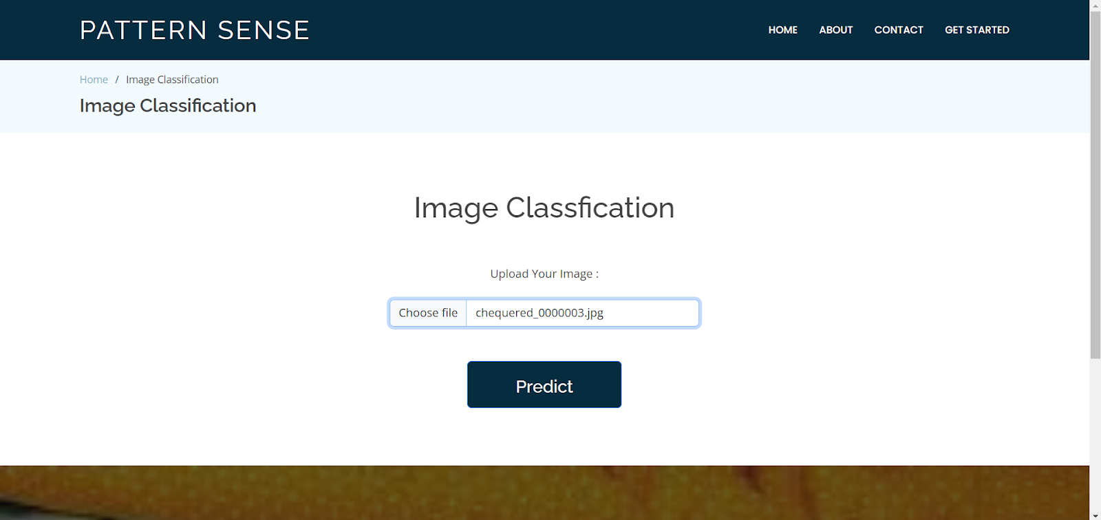

Output:2

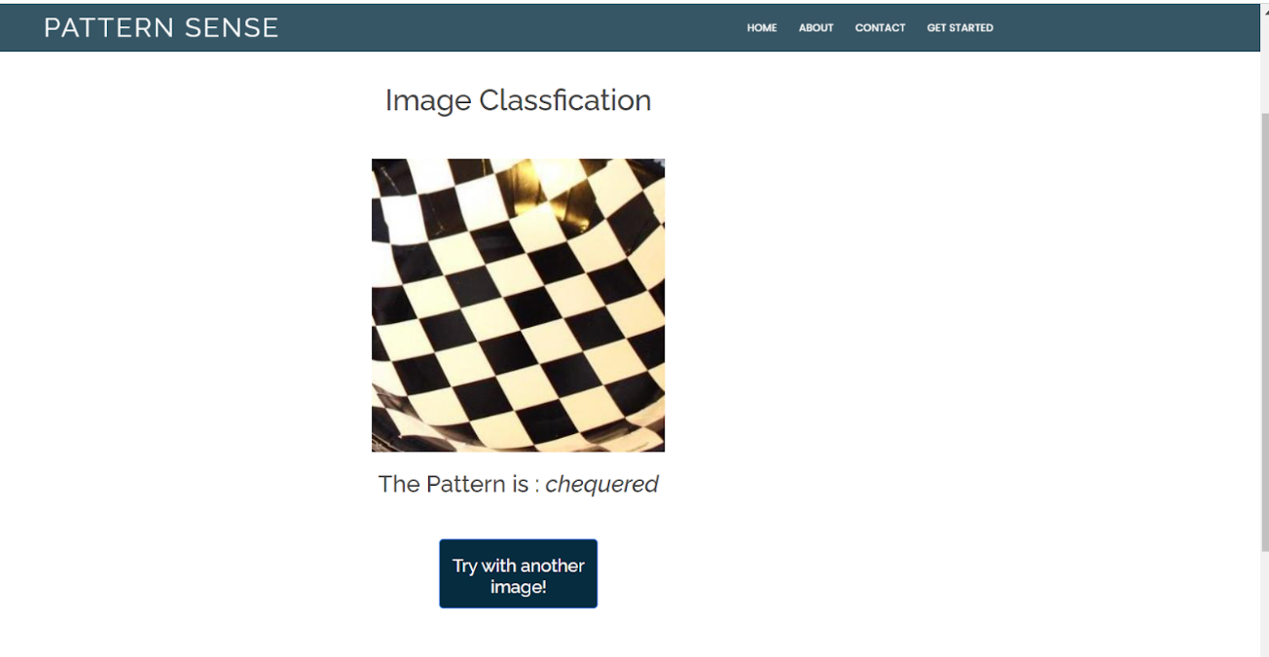

1. **Advantages & Disadvantages:**

**✅ Advantages**

| **Category** | **Description** |
| --- | --- |
| 🎯 **High Accuracy** | Deep learning models (CNNs) offer excellent performance in pattern recognition tasks. |
| 🔁 **Modular Design** | Frontend, backend, and ML components are decoupled—making it easier to update/replace any layer. |
| ⚙️ **Scalable Architecture** | Microservice-like separation (React ↔ Node.js ↔ Flask) allows for scalable deployment. |
| 🔐 **Secure (with Auth)** | JWT-based authentication and authorization protect API endpoints and user data. |
| 🌍 **Cross-Platform Access** | React frontend is responsive and can be accessed on any device (mobile/desktop). |
| 🧠 **Reusable Model** | ML model can be reused in other applications (mobile app, APIs, etc.) with minimal changes. |
| 🧪 **Testable** | Clear separation of concerns makes unit and integration testing easier. |
| 🧰 **Open-Source Friendly** | Uses common, open-source technologies: React, Node.js, Flask, TensorFlow. |
| 🔄 **Real-time Feedback** | Users get immediate predictions after uploading fabric images. |

**❌ Disadvantages**

| **Category** | **Description** |
| --- | --- |
| 🐢 **Latency** | Sending data through 3 layers (React → Node → Flask) may introduce delays. |
| ⚙️ **Model Server Complexity** | Hosting and maintaining a separate ML server (Flask) increases deployment complexity. |
| 🧠 **Model Training Required** | Requires labeled dataset and retraining if new fabric patterns are added. |
| 📦 **Storage Costs** | Storing large numbers of fabric images or models may increase storage/hosting costs. |
| 🔄 **Dependency Overhead** | Many moving parts and dependencies across JS and Python ecosystems. |
| ❌ **Cold Start Issue (Flask)** | If the ML server is on-demand (serverless), initial requests can be slower. |
| 🧑‍💼 **User Management is Minimal** | Basic JWT auth may not be enough for enterprise-grade roles/permissions unless extended. |
| 🔒 **Security Risks (if unprotected)** | If JWT or file upload isn't validated securely, system can be vulnerable. |

**12.Conclusion :**

| **When it’s Ideal** | **When It Might Not Be Ideal** |
| --- | --- |
| You need a web-based visual tool to classify fabrics | You want a very lightweight, all-in-one desktop solution |
| You plan to scale to mobile/web/API systems | You're unfamiliar with both Python & JavaScript stacks |
| **You expect to enhance the ML model over time** | **You don’t have access to GPU training or model tuning** |

1. **Appendix:**

**>> Github link: https://github.com/vijay-2004-kayala/classifying_fabricpatterns_using_deeplearning**